Chapter 8, Problem 58.

In the circuit of Fig. 8.104, the switch has been in position 1 for a long time but moved to position 2 at t = 0. Find:

- v(0⁺), dv(0⁺)/dt
- v(t) for t ≥ 0.

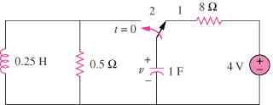

Figure 8.104
For Prob. 8.58.

